**structure**

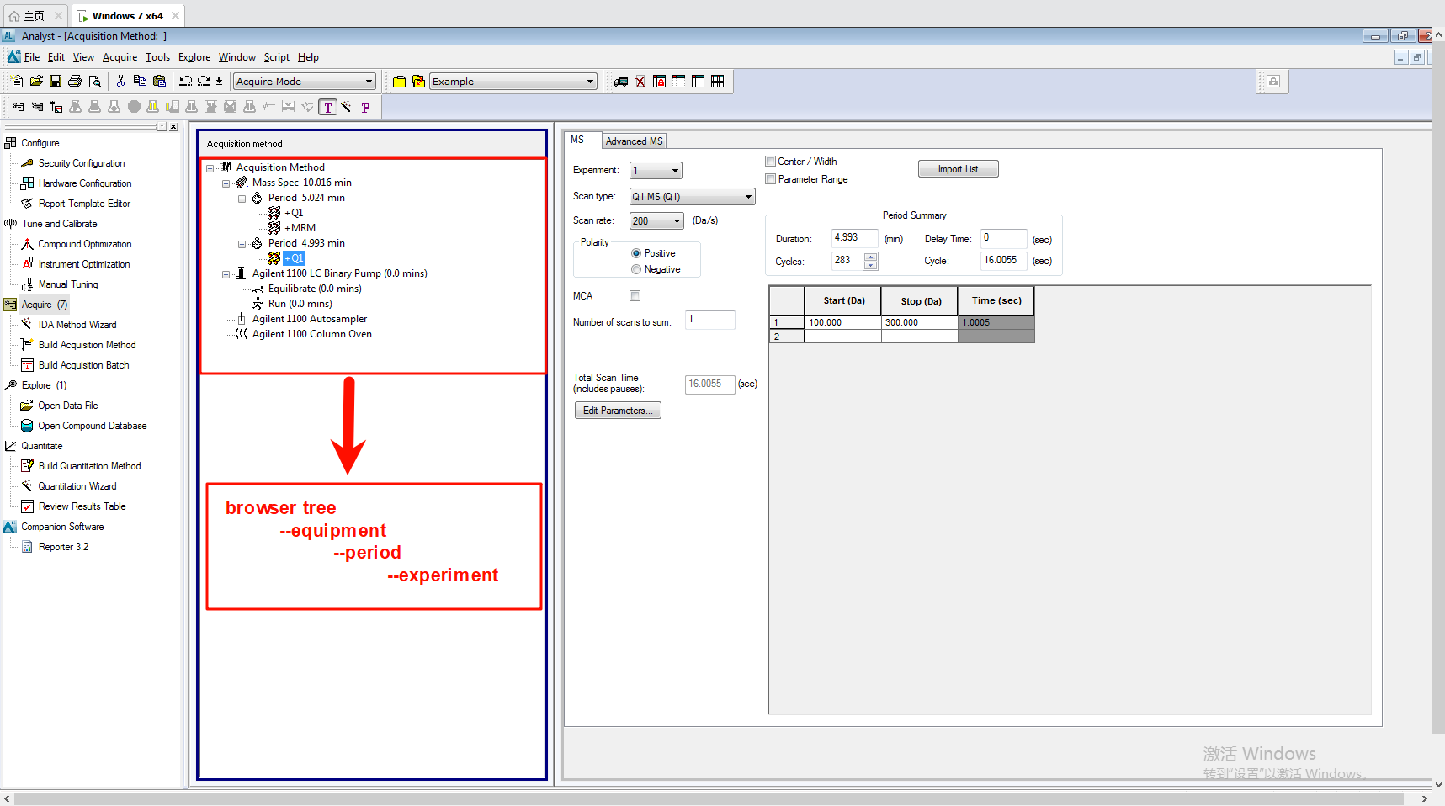

**scan**

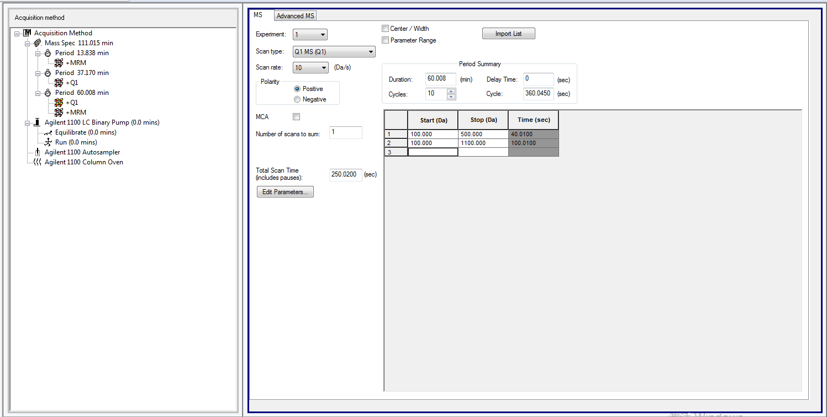

formula

time = (mass range/scan rate) + (step size/scan rate)

total scan time = (time_1 + pause time + time_2 + pause time + ... + time_n + pause time) + settling time

duration time = (time_1 + pause time + time_2 + pause time + ... + time_n + pause time) * cycles + settling time

**mrm**

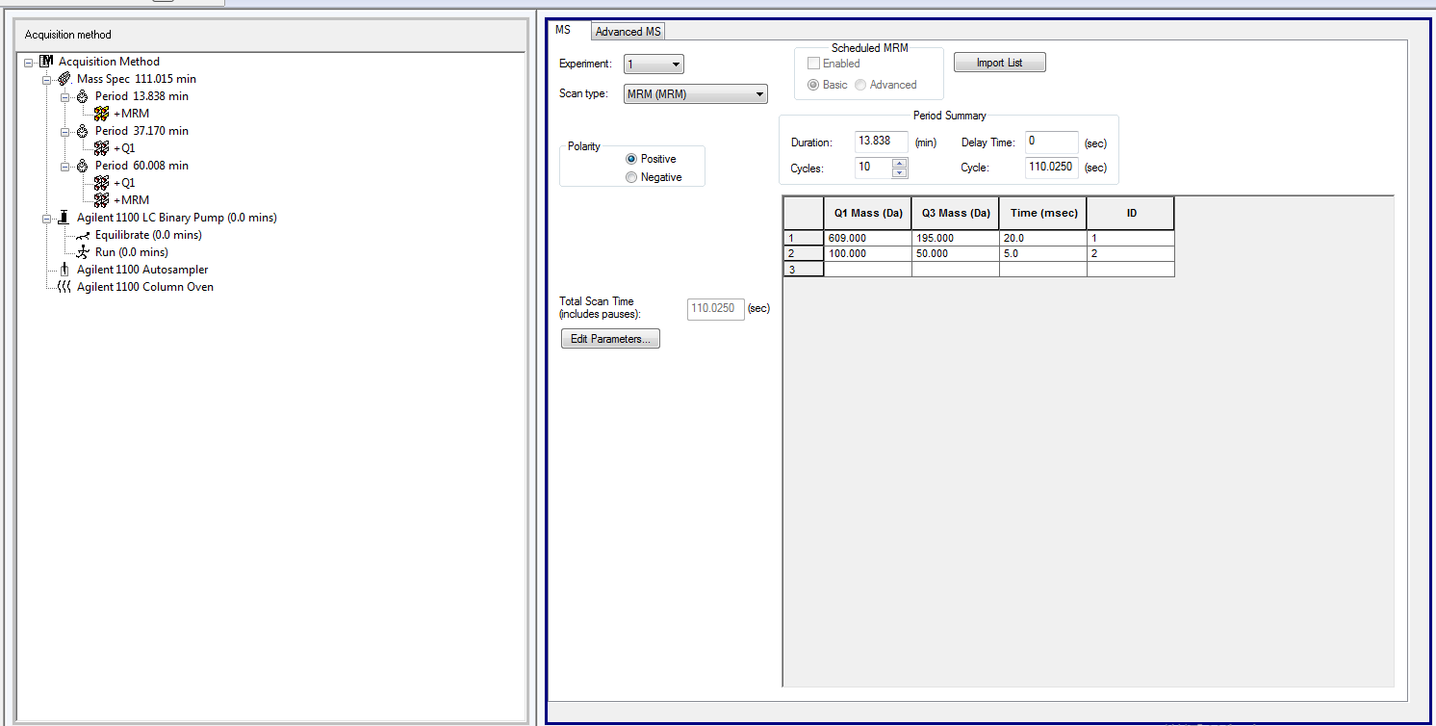

formula

total scan time = time_1 + pausing time + time_2 + pausing time + settling time

duration time = 没搞定

**peroid time**

cycle time = (experiment_1's total scan time) + (experiment_2's total scan time)

peroid time = duration time

MRM的duration time没搞定

**equipment time**

equipment time = peroid_1(duration time+delay time) + peroid_2(duration time+delay time) +...+ peroid_n(duration time+delay time)